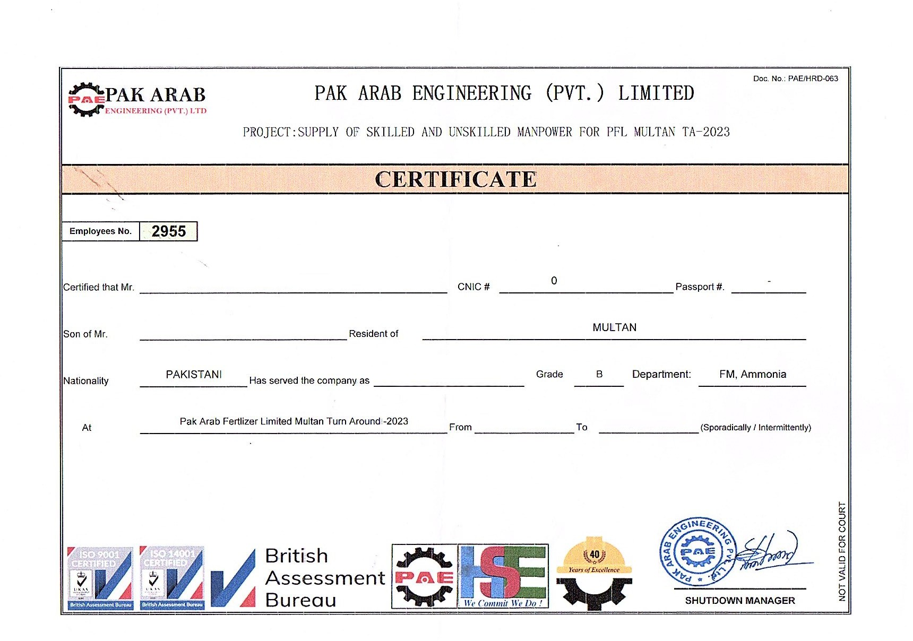

**<Name>**

**<fname>**

**<Designation>**

**<From>** **<To>**